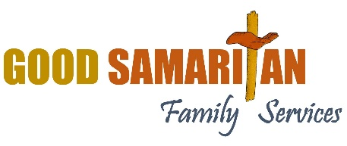
Tee Up For Families Sponsorship Opportunity
Hello! I hope this letter finds you well. I am reaching out on behalf of Good Samaritan Family Services. We are hosting a fundraiser golf outing on August 24th at Antrim Dells Golf Course.
Many of you may be familiar with Good Samaritan Family Services, but for those of you who are not, we are here to help the hurting people in our community. We have a food pantry that is partially subsidized by our retail shop and furniture store, and we help people with their utilities bills when needed. We have a family center for Moms and their children up to age 5 where they get help, food, formula, baby items and most importantly build relationships to help them parent. We are also working on ways to keep dads involved with their families. We serve over 2400 people every month! For more information, please check out our website at www.thegoodsam.org.
We are seeking sponsors to help make this event a success. As a sponsor, your organization will gain;
Visibility: Your logo will be featured on all event materials, including flyers, banners, and our website.
Recognition: Acknowledgment during the event and in our promotional efforts.
Community Impact: An opportunity to show your commitment to helping our Northern Michigan Community.

We have three different sponsorship levels:
Gold Hole Sponsor - $750 (large sign on tee and in program)
Silver Hole Sponsor - $500 (medium sign on tee and in program)
Bronze Hole Sponsor - $250 (small sign on tee and in program)

Would you please consider being a sponsor for this event? It makes such a difference in helping this be a success!
We are also in need of raffle prizes. If you would like to donate a raffle prize, it would be greatly appreciated and be another opportunity to have your business mentioned!
No matter how you help, please know that you are helping many people in our community, and we are so thankful for it! A receipt of payment with our 501[c](3) number will be provided to you for your charitable gift contribution.
Please fill out the included form and send it back to me in the enclosed envelope by July 1, 2025. I would love to schedule a time to discuss this opportunity further and answer any questions you may have. Thank you for considering partnering with us in making a difference in our community.
Warn Regards,
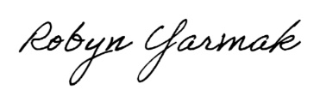
Robyn Yarmak
Executive Director

